* Majd Farid Abbas
* Address: Erbil, aekawa, Iraq
* Tel: 07803655541
* Email: magdabbas0@gmail.com
* Date of birth: 1– 1 - 1992
* Nationality: Syrian
* Gender: Male
* Reliable, motivated and enthusiastic individual with a broad understanding of customer service, communication with diverse people, professional sales developer, good knowledge of professional project management, topographical and geology sciences in many companies, I am a very flexible person who can work extra, and later hours.

# WORK HISTORY

* **quality engineer In JOUD FACTORY For the cheese industry**
* **quality engineer In the agricultural development company**
* **quality engineer In the Rawabi For Agricultural company**
* **quality engineer In Coca-Cola Factory**
* **Experience in technological engineering and biological sciences in agriculture**
* **Experience in designing machines, equipment and agricultural structures**
* **Experience in developing soil and water conservation methods**
* **Experience in improving and processing agricultural products**
* **Experience in producing plans for dairy laboratories, irrigation and drainage**
* **Experience in assessing environmental impacts on crops**
* **Danora campany : ( lattakian port , Syria )**
* **Which is specialized in shipping and customs clearance all over the world.**
* **(five years of experience ) as a sales man in Danora’s Company , I started as a worker for one year**
* **Before I became a supervisor who is in charge of over 23 workers together.**
* **In charge of loading and discharging goods to transport them safety.**
* **A presentative of Danora’s company concerning marketing products and services the company offers.**
* **Company name : OUDEH PETROLEUM COMPANY**
* **Location: LATTAKIA , Syria**

### **Job title: Surveyor, safty man**

* + Maintain the safety and safety of workers in the oil field during working time.  
    • To guide workers to take serious and productive work in order to obtain positive results later.  
    • Conduct a topographic survey of the field.  
    • Take accurate coordinates and transfer them to the processing and interpretation devices.  
    • Ensure the quality of solid materials in the field for do not make future errors.  
    • Easy communication and flexible handling with the rest of the workers, management staff and engineers supervising the project.  
    • Gain good experience in dealing with international companies investing in gas and oil in the country.  
    • Get used to working extra hours to get the required results as soon as possible**.**
* **Company name : LG TURKISH SERVICE COMPANY " BUILDING ROADS AND BRIDGES "**
* **Location: Duhok, Iraq**

### **Job title: Surveyor**

* + Construction of a wide and fast road between Datuk and Sakho  
    • Examination of the types of soil and gravel used in road brushes  
    • Take the exact measurements and measurements of the field and turn them into plans later  
    • Taking measurements of the degree of soil aggregation after heavy machinery  
    • Provide management reports every day after completion of work

# EDUCATION

* From2009
* To 2012 **Tishreen UNIVERSITY Lattakia** **, Syria** ***three stages in General*****Agricultural *engineer***
* 2014 **ICDL Lattakia , Syria**
  + - *Computer training course (7 weeks course) س*
* 2016 **Graduation Project Lattakia , Syria** ***Specialization of field crops***

# TECHNICAL SKILLS

* Ability to use computer, Microsoft Office, word, Excel, PowerPoint, and access.
* Browsing internet, using emailing facilities and installing and downloading programs and applications.
* Computer programming, software and hardware experience and skills
* Excellent organizing, planning and conducting distribution activities.
* Excellent experience and abilities of work with customers and conducting selling
* Building relationships, coordination and negotiation/ good skills.
* Excellent team work member. Easy approachable and manageable.
* Have the ability to work for longer times, and flexible for the work purposes.
* Very good time management, organization and planning skills.

# LANGUAGES

|  |  |  |  |  |
| --- | --- | --- | --- | --- |
| * **Languages** | * **Understanding** | * **Speaking** | * **Writing** | * **Reading** |
| * **English** | * Fluency | * Fluency | * Fluency | * Fluency |
| * **Arabic** | * Fluency | * Fluency | * Fluency | * Fluency |
| * **France** | * Fluency | * Fluency | * Fluency | * Fluency |

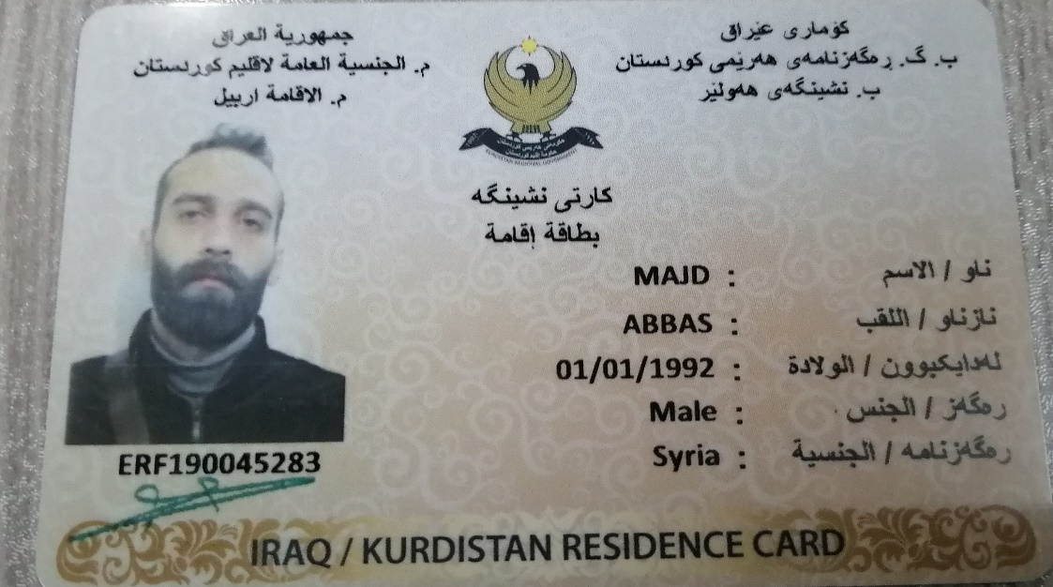

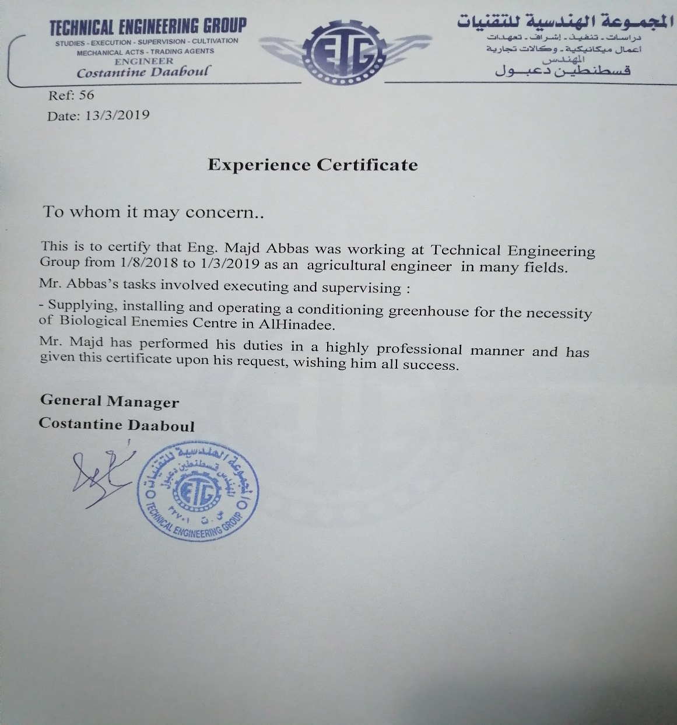

س